The Edwinstree Middle School Physical Education Journey

**Year 5 – Introducing PE at Edwinstree**

Your Physical Education Journey starts here …

Autumn

Term

Spring

Term

Summer

Term

**Football**

You will look at the basic skills of the game through small sided games and develop your understanding of small sided game tacitcs

**Swimming**

You will be introduced to the four basic strokes and begin to look at diving.

**Hockey**

You will cover basic skills and the foot rule is introduced

**Basketball**

You will cover dribbling, passing and the set shot focussing specifically on the BEEF principle

**Tag Rugby**

You will cover basic skills and learn how to play the game through small sided games

**Gymnastics & Dance**

Using the British gymnastics core proficiency standards you will learn new skills and begin to develop a routine.

**Swimming**

You will begin to look at some lifesaving techniques and continue to develop your knowledge of the four basic strokes.

**Netball**

You will cover basic skills and begin to look at a range of rules.

**Athletics**

You will cover sprinting, long jump and a throwing discipline. This unit will also cover sports day prepeartion

**Rounders**

You will look at striking and fielding skills through gameplay

**Tennis**

Focus will be on the game of short tennis and building fundamental forehand and backhand striking

**Cricket**

You will look at the game of Kwik Kricket and learn fundamental skills through this.

Show Your Commitment

How many can you complete?

**Bring your kit to EVERY lesson**

**Attend an extra-curricular club each term**

**Represent EMS in sport**

**Embody our Christian values**

Fixtures Each Year

**Football**

**Kwik Kricket**

**Tag Rugby**

**Basketball**

**Sportshall atheltics**

**Netball**

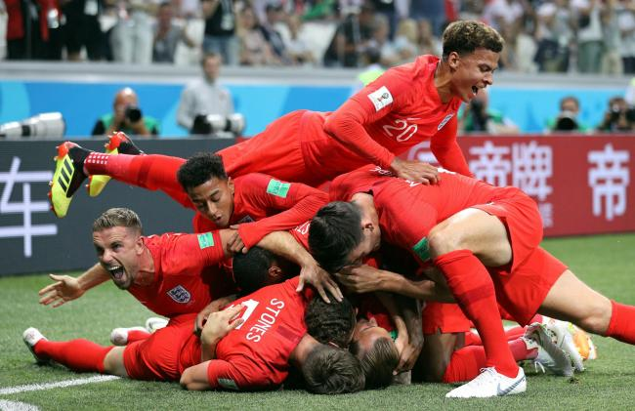

Can you name the sports stars? 10 merits if you can name 10!

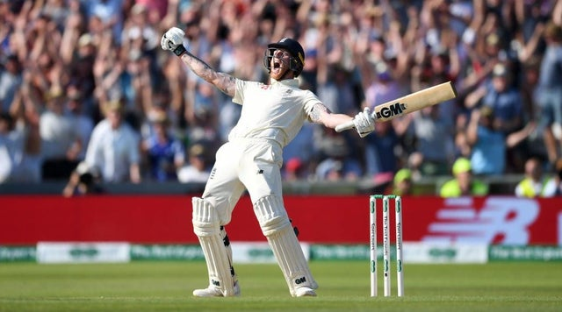



**Handball**

You will cover the basic rules of handball and look at gameplay

.

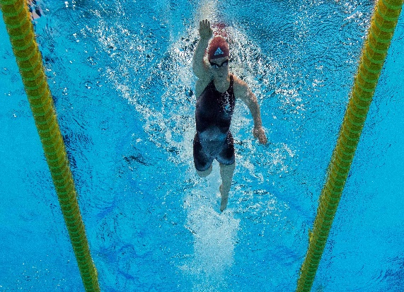

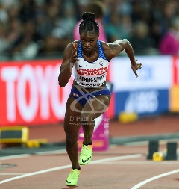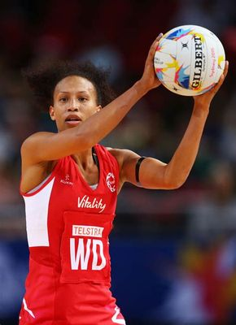

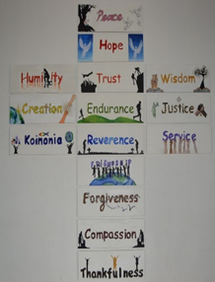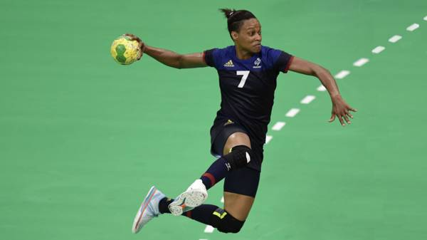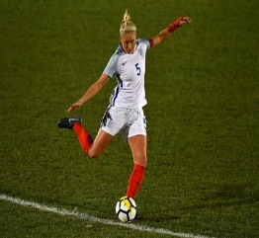

**Football**

You will look at the basic skills of the game through small sided games and develop your understanding of small sided game tactics.

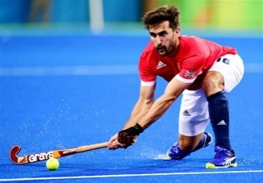

**Hockey**

You will cover basic skills and the foot rule is introduced.

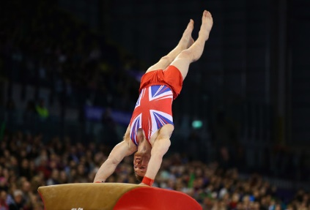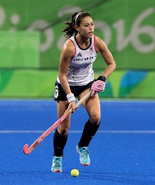

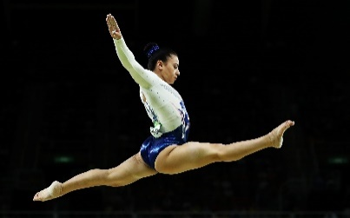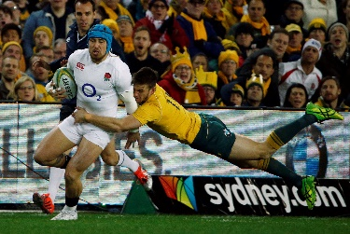

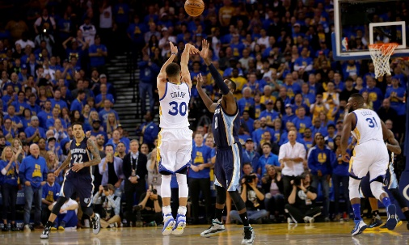

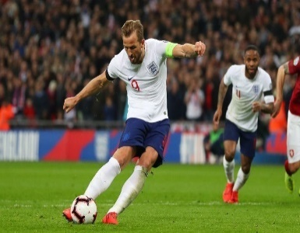

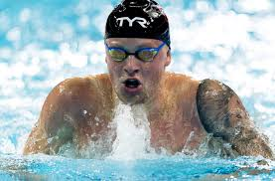

Key:

Boys Lesson:

Girls Lesson:

Mixed Lesson: