The Edwinstree Middle School Physical Education Journey

**Year 6 – Developing my skills and game knowledge**

Your Physical Education Journey continues here …

Autumn

Term

Spring

Term

Summer

Term

**Handball**

You will begin to look at the setup of a handball game more closely and develop your throwing and catching skills

**Swimming**

You will look to achieve swimming 25m competently in a recognised stroke.

**Hockey**

You will look at different types of tackle when defending and different ways of shooting when applying this to games

**Basketball**

You will begin to look at attacking and defending principles and how to use skills in recognised gameplay.

**Tag Rugby**

You will develop your learnt skills from Year 5 and apply this to larger sided games.

**Gymnastics & Dance**

You will develop the skills you learnt ion Year 5 and build more sophisticated routines. You will laso look at vaulting in more depth

**Swimming**

You will look at some more advanced lifesaving techniques and begin to look at the sport of water polo.

**Netball**

You will begin to look at how a netball game is structured and gain an idea of specific positions

**Athletics**

You will cover sprinting, long jump and a throwing discipline. This unit will also cover sports day prepeartion

**Tchoukball**

You will be introduced to the sport of Tchoukball

**Tennis**

Focus will be on the game of short tennis and building fundamental forehand and backhand striking

**Cricket**

You will begin to look at overarm bowling as a technique within Kwik Kricket. Alongside developing the skills you learnt in Year 5

Show Your Commitment

How many can you complete?

**Bring your kit to EVERY lesson**

**Attend an extra-curricular club each term**

**Repreent EMS in sport**

**Embody our Christian values**

Fixtures Each Year

**Football**

**Kwik Kricket**

**Tag Rugby**

**Basketball**

**Sportshall athletics**

**Netball**

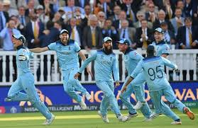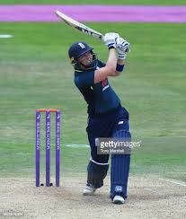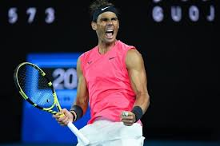

Can you name the sports stars? 10 merits if you can name 10!

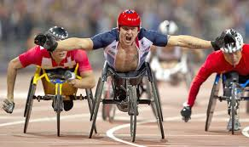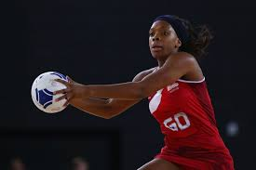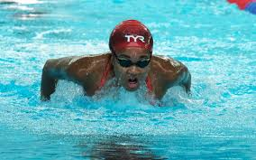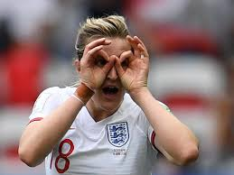

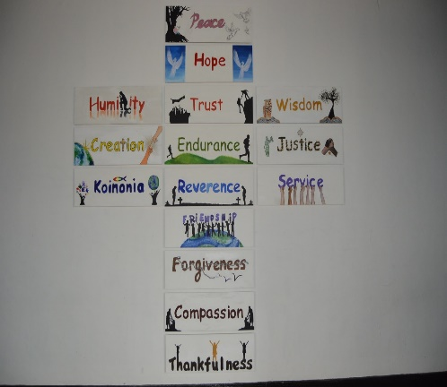

**Football**

You will begin to look at more advanced skills and apply this to larger sided games

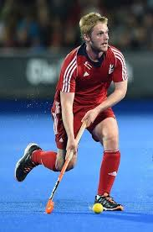

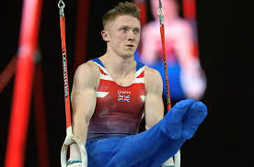

**Hockey**

You will look at different types of tackle when defending and different ways of shooting when applying this to games

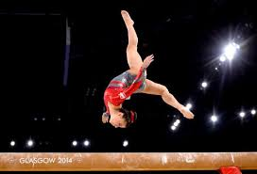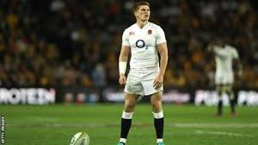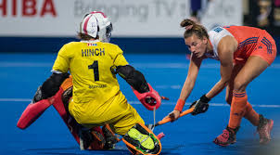

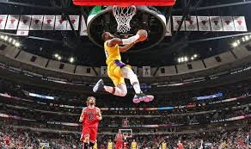

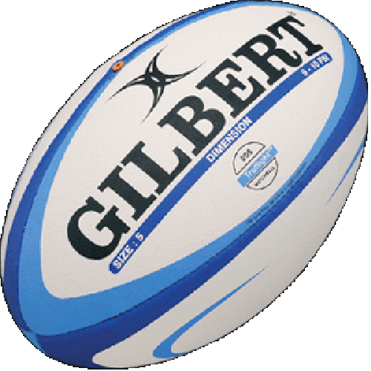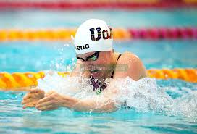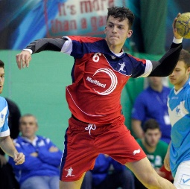

Key:

Boys Lesson:

Girls Lesson:

Mixed Lesson: