The Edwinstree Middle School Physical Education Journey

**Year 7 – Developing my skills in competitive scenarios**

Your Physical Education Journey continues here …

Autumn

Term

Spring

Term

Summer

Term

**Football**

You will look to use your learnt skills from KS2 in gameplay and begin to look at organised positions

**HRE**

You will look at fitness testing and challenge yourself against standardised scoring. Ideas of Health Related Fitness and Skill related fitness will be introduced

**Hockey**

You will learn attacking and defending principles in Hockey through small-sided games

**Basketball**

You will look at types of defence and how the game is structured. You will learn about the lay up

**Rugby**

Contact rugby is introduced through small-sided games and practices. You will learn how to tackle and ruck.

**Gymnastics & Dance**

You will look at four major skills within gymnastics; rolling, handstands, cartwheels and vaulting.

**Outdoor and Adventurous Activity**

You will look at soft skills such as teamwork through problem solving and orienteering is introduced

**Netball**

You will begin to look at how a netball game is structured and gain an idea of specific positions

**Athletics**

You will work in teams across the unit to complete a series of events and earn points for your team.

**Rounders**

You will look at the rules of the game in depth and learn through competitive matches

**Tennis**

The more traditional game of tennis is introduced and you will look at ways to beat your opponent using different tactics

**Cricket**

Fielding skills are a focus before developing into small sided matches of cricket

Show Your Commitment

How many can you complete?

**Bring your kit to EVERY lesson**

**Attend an extra-curricular club each term**

**Repreent EMS in sport**

**Embody our Christian values**

Fixtures Each Year

**Football**

**Cricket**

**Rugby Rugby**

**Basketball**

**Sportshall athletics**

**Netball**

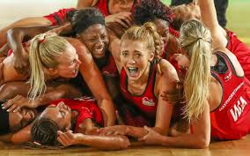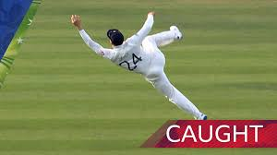

Can you name the sports stars? 10 merits if you can name 10!

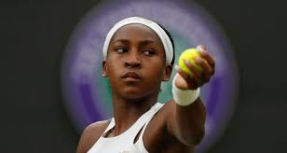

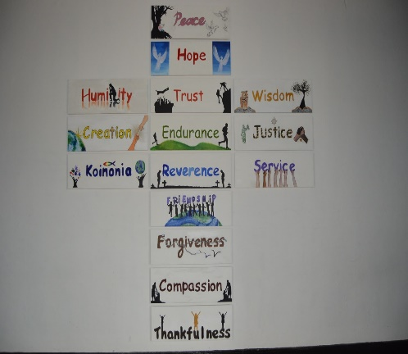

**Handball**

You will look to develop your knowledge of the handball game and begin to play a less adapted format of the game

**Football**

You will look to use your learnt skills from KS2 in gameplay and begin to look at organised positions

**Hockey**

You will learn attacking and defending principles in Hockey through small-sided games

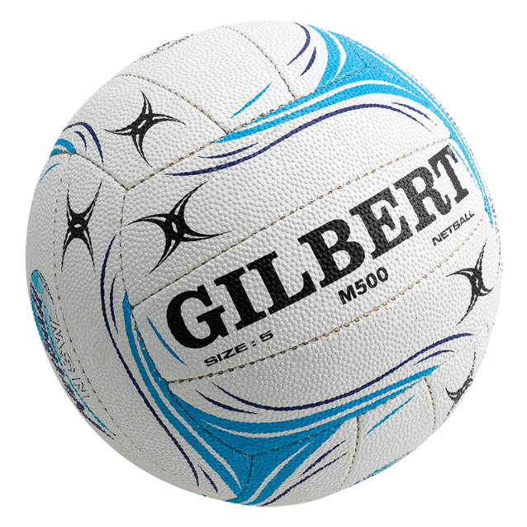

Key:

Boys Lesson:

Girls Lesson:

Mixed Lesson: