The Edwinstree Middle School Physical Education Journey

**Year 8 – Applying my skills in competitive scenarios**

Your Physical Education Journey continues here …

Autumn

Term

Spring

Term

Summer

Term

**OAA**

You will develop your map work in competitive orienteering and look to use compasses

**HRE**

You will look at fitness testing and challenge yourself against standardised scoring. You will use the Couch25k to improve your fitness

**Lacrosse**

You are introduced to the game through small sided games

**Table Tennis**

You will look at how to use different types of shot to beat an opponent

**Rugby**

Game play is taken into larger teams and the concepts of positions are introduced

**Gymnastics & Dance**

You will look at four major skills within gymnastics; rolling, handstands, cartwheels and vaulting.

**Volleyball**

You will be introduced to the set, spike and dig through small sided games

**Netball**

You will begin to look at how a netball game is structured and gain an idea of specific positions

Athletics

You will work in teams across the unit to complete a series of events and earn points for your team against the ESAA standards

**Rounders**

You will look at the rules of the game in depth and learn through competitive matches

**Tennis**

The more traditional game of tennis is introduced and you will look at ways to beat your opponent using different tactics

**Cricket**

Pairs cricket is used in larger scale matches to apply your learnt skills

Show Your Commitment

How many can you complete?

**Bring your kit to EVERY lesson**

**Attend an extra-curricular club each term**

**Repreent EMS in sport**

**Embody our Christian values**

Fixtures Each Year

**Football**

**Cricket**

**Rugby Rugby**

**Basketball**

**Sportshall athletics**

**Netball**

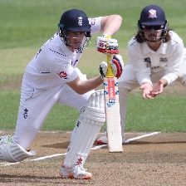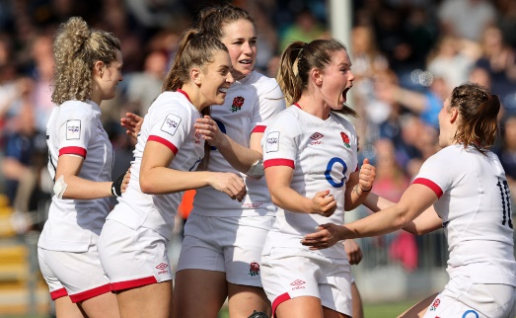

Can you name the sports stars? 10 merits if you can name 10!

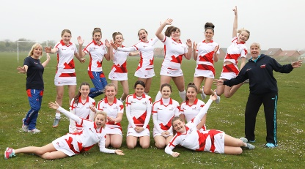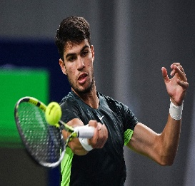

**Basketball**

You will play attack vs defence 3v3 and develop this into conditioned games

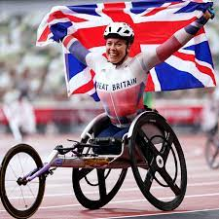

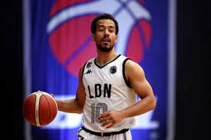

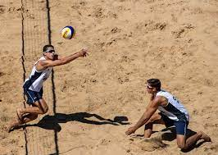

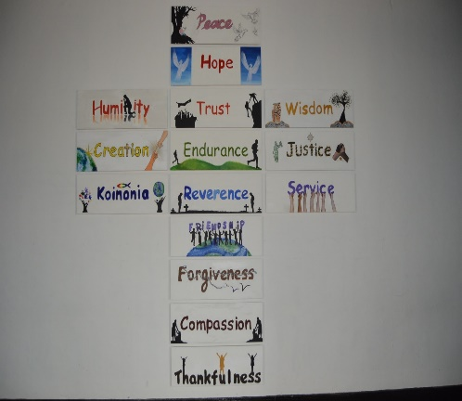

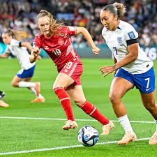

**Football**

You will use sport education to look at coaching, playing and officiating

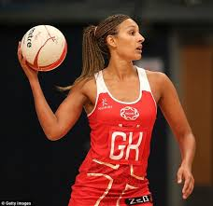

**Hockey**

You will develop your skills around attacking and defending in larger games

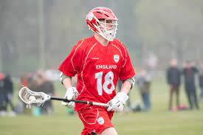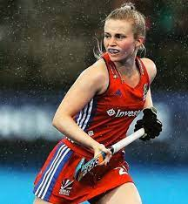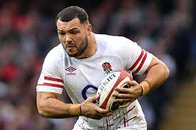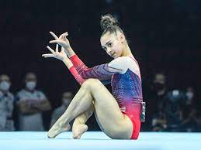

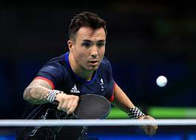

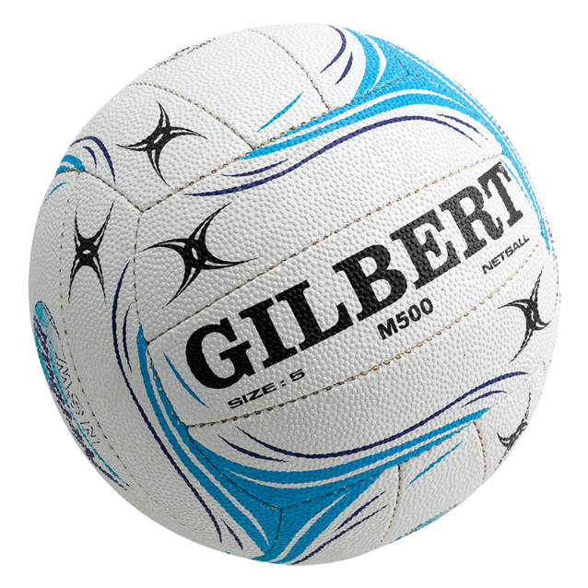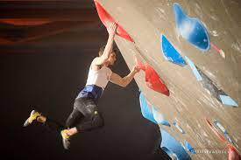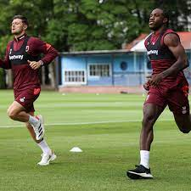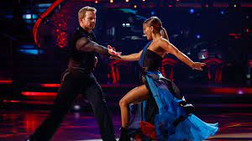

**Dance**

You will look explore the dance genre of Capoeira