Previous learning- Christianity and Atheistic Worldviews
TOPIC- Creation and the Fall
Threshold- Look at Christian views on creation, consider supporting arguments such as design and causation.

Threshold- Consider Islamic, Sikh and Hindu views on creation
Threshold- Realise that religion can disagree within itself and work with science also
Threshold- Consider the impact of the Fall on society today
Future Learning- Jesus- who was he and who is he today?

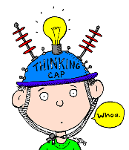
I deepened my thinking this term when I…

Previous learning- Creation and the Fall
TOPIC- Jesus- who was he and who is he today?
Threshold- Consider the symbolism within the nativity and what we can infer from it
Threshold- Look at how parables and miracles give an insight into Jesus
Threshold- Explain the role of the resurrection in Jesus’ life/purpose
Threshold- Consider how prejudice affects how society sees Jesus today
Future Learning- Christianity in the Modern World

I deepened my thinking this term when I…

Previous learning- Jesus- who was he and who is he today?
TOPIC- The Problem of Evil
Threshold- Define the Problem of Evil
Threshold- Outline several Christian responses to it
Threshold- Consider Islamic, Hindu and Buddhist responses to it
Threshold- Explain their own views on the Problem of Evil
Future Learning- Y8 The Death Penalty

I deepened my thinking this term when I…

