Previous learning- Jesus- who was he and who is he today?
TOPIC- The Problem of Evil
Threshold- Define the Problem of Evil
Threshold- Outline several Christian responses to it
Threshold- Consider Islamic, Hindu and Buddhist responses to it
Threshold- Explain their own views on the Problem of Evil
Future Learning- Y8 The Death Penalty

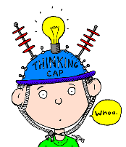
I deepened my thinking this term when I…

Y8 Spring and Summer Threshold Concepts
RE is currently being re-written, to allow appropriate planning time the Spring and Summer SOW will be written during the academic year of 2023-2024.
As soon as they are available they will be published on the website.
Thank you for your patience as we navigate this exciting time in RE!
Mrs Kelly HOD RE

